Title

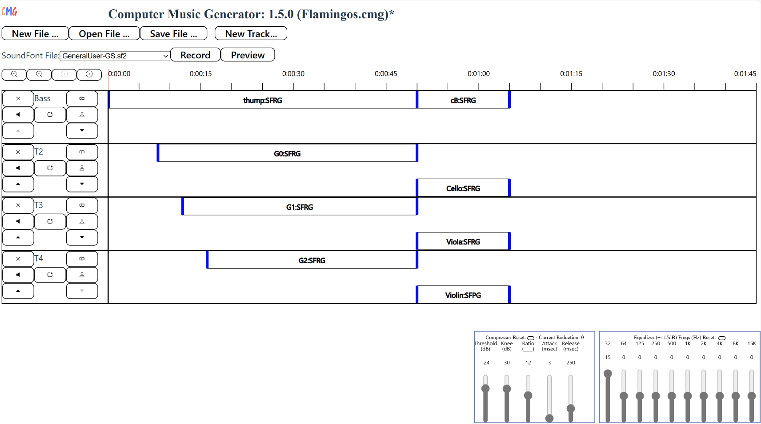

Status Message Area

Room Compressor and Equalizer

Generator

Preview and Record Buttons

Timeline and Controls

SoundFont Selector

File and Track Menus

Track Display and Control Area